**RICH RADKE D.I.P**

**HISTOGRAMS AND POINT OPERATIONS**

Used to improve contrast of washed-out image

Histograms are not one-to-one mapping of an image, because different images can have same histograms. It is not unique to an image.

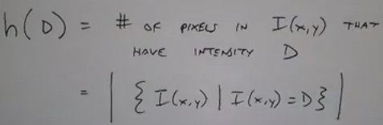

Mathematical representation of histogram

**Threshold** is a point operation

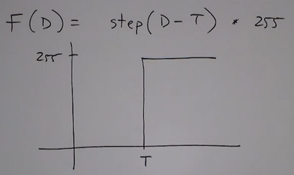

**Digital negative (inverting)**

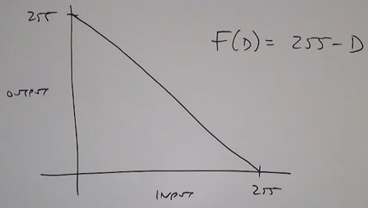

**Contrast stretching:**

Uses the entire histogram. Sometimes if a portion of the image (like a frame/photo) is washed out you can also squeeze the histogram to narrow down on those details.

The first portion 255/(H-L) is the slope of the line

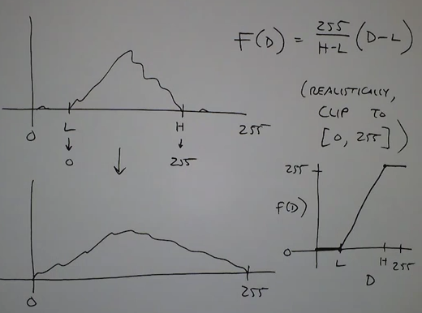

**Histogram equalization**:

In some images contrast stretching alone would not work. Because if you do so either dark portions become darker or bright portions become washed out. Hence a linear mapping of pixels will not help,

Non-linear mapping helps in such cases.

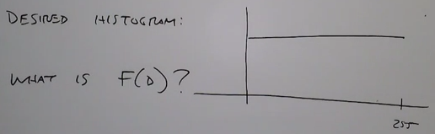

Basic idea is to think of image histogram as a probability mass function.

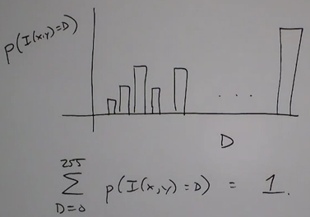

We should be using the cdf:

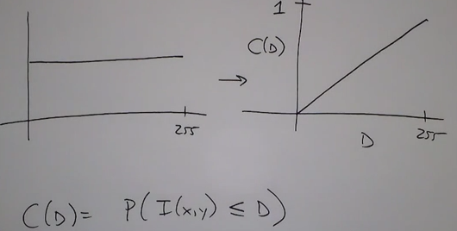

We want our image histogram to be mapped in the above manner.

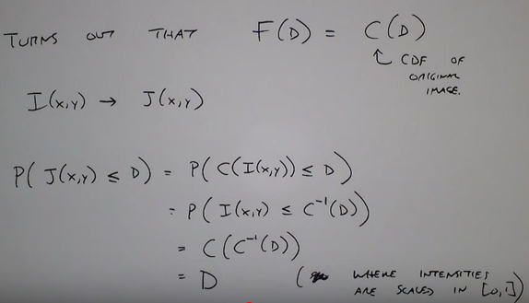

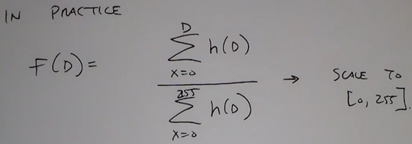

Comparison of original histogram and equalized histogram:

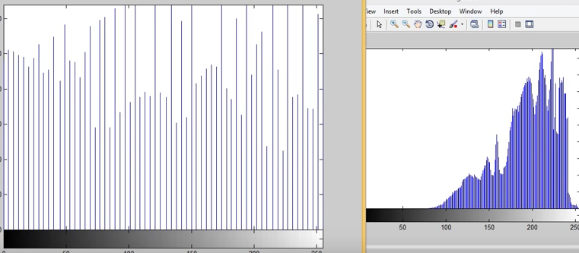

Histogram equalization is applied equally to all pixels having the same intensity. Hence pixels in biger bars cannot be combined (on right) but pixels in smaller bars can be combined (on left). Hence darker regions of image will not be clear while brighter portion of image would have been enhanced.

**Histogram Specification:**

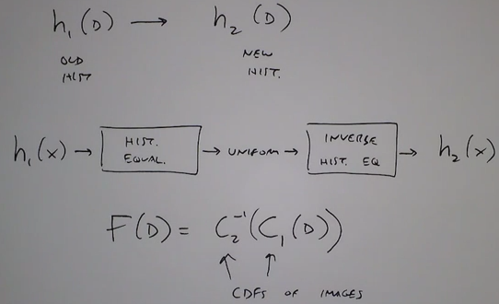

**Gamma Correction**

Every display device has a different non-linear relationship between pixel input intensity and display output luminance. (relation between current and voltage not linear in the cathode tube)

The relationship for real devices is often modeled as a power function: 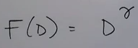

(Gamma correction is an act of compensating the input so that the output looks in the manner desired.)

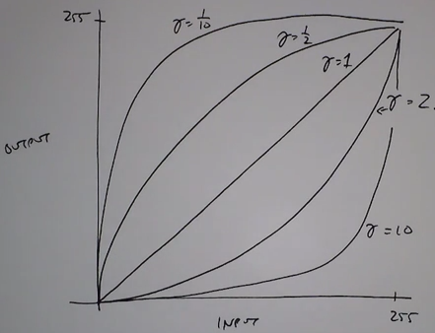

If we know the ‘gamma’ value of the display device then we can precompensate the intensities.

All above mentioned point operations affect every pixel with the same intensity in the same way, these were global operations. So we go for operations that are more local, eg: spatial filters.

Eg of spatial filter replace each pixel in image by the average of all its neighbors:

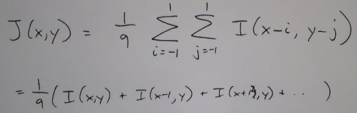

Projective Transformation:

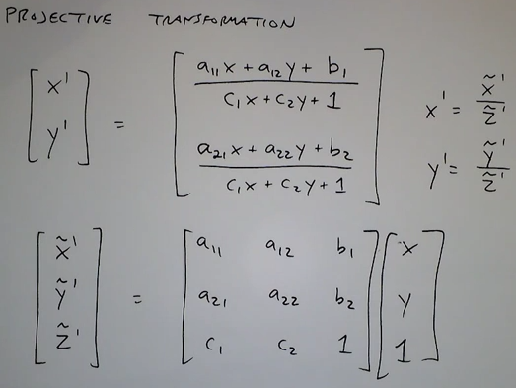

‘c1’ and ‘c2’ control how skewd an image is.

Sometimes you might not get the output image in integer, but some non-integer positions (below):

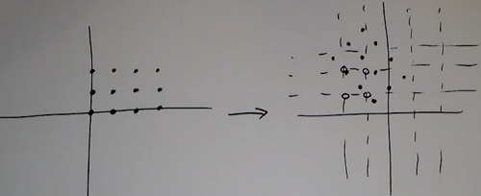

Question is how to get image color/intensities on the new grid?

It is conventional to use backward mapping.

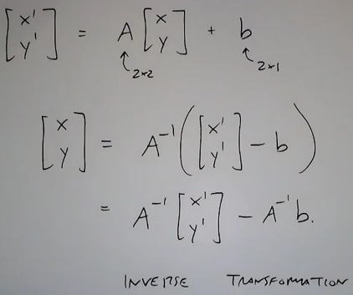

Pixel intensities in the new image can be filled using either of the following operations:

* Nearest neighbor interpolation
* Bilinear
* Bicubic

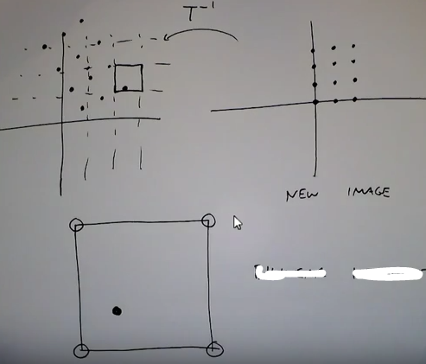

*Bilinear interpolation:*

Now there are three positions where a pixel may fall:

* On the point exactly
* Between two points along a grid
* Somewhere in the square

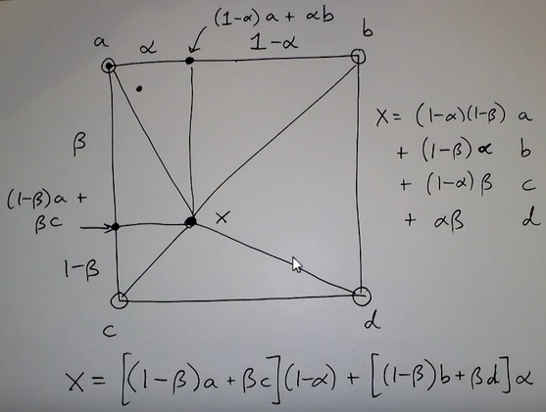

*Bicubic interpolation:*

Consider 16 points as neighbors to compute intensity values. Result is a much more smoother image than bilinear but more computational.

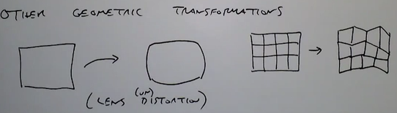

**SPATIAL FILTERING**

In 1-D it is called the ‘Time Domain’, with the central element of the filter called the ‘zero element’.

* [ -1, 2, -1]

In 2-D it is called the ‘Spatial Domain’

Enhancing the edges also enhances the noise(too much of color intensity is added).

To avoid the noise being sharpened we use ‘unsharp mask’ technique.

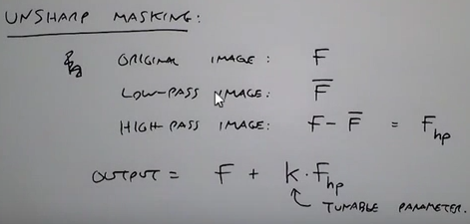

We add a fraction of the edges back in for a more subtle effect.

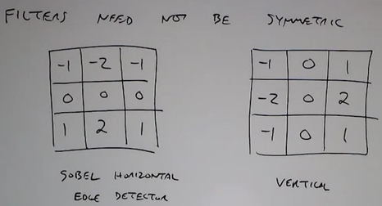

Not all filters are linear, eg: median filter: to eliminate ‘salt and pepper’ noise.

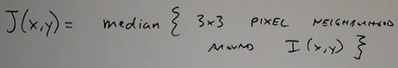

Median filtering is an example of non-linear filtering because there is no averaging done based on entire collection of pixels in filter but it is just a pixel-dependent choice making it non-linear filter.